**PSG SIGNAL ANALYSIS**

PSG stands for Polysomnography; PSG audio/signal are the signal obtained through lab-based polysomnography test which is used for detecting Obstructive Sleep Apnea(OSA).

PSG signal consists of -

**EEG (A1-A2, C3-A2, C4-A1)**: Electroencephalogram signals measuring brain activity.

**EOG (LOC-A2, ROC-A2)**: Electrooculogram signals measuring eye movements.

**EMG (Chin, Leg 1, Leg 2)**: Electromyogram signals measuring muscle activity.

**ECG I**: Electrocardiogram signal measuring heart activity.

**RR**: Respiratory rate signal, showing breathing patterns.

**Snore**: Signal indicating snoring events

**Flow (Patient)**: Respiratory airflow signals. These are critical for understanding breathing patterns and any obstructions.

**Effort (THO, ABD)**: Thoracic and abdominal effort signals showing the effort put into breathing.

**SpO2**: Oxygen saturation level in the blood.

**Body, PulseRate, Mic**: Various other signals that might include body position, pulse rate, and microphone recordings.

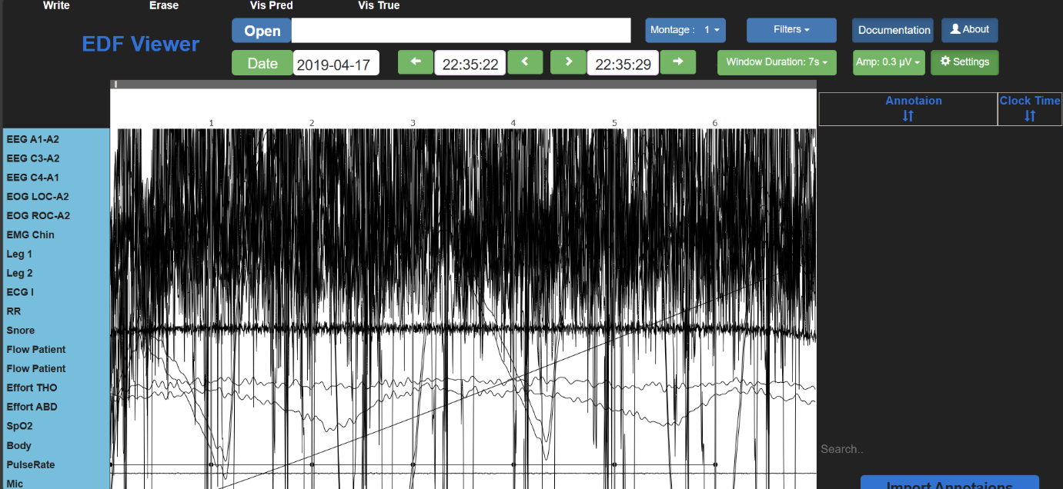

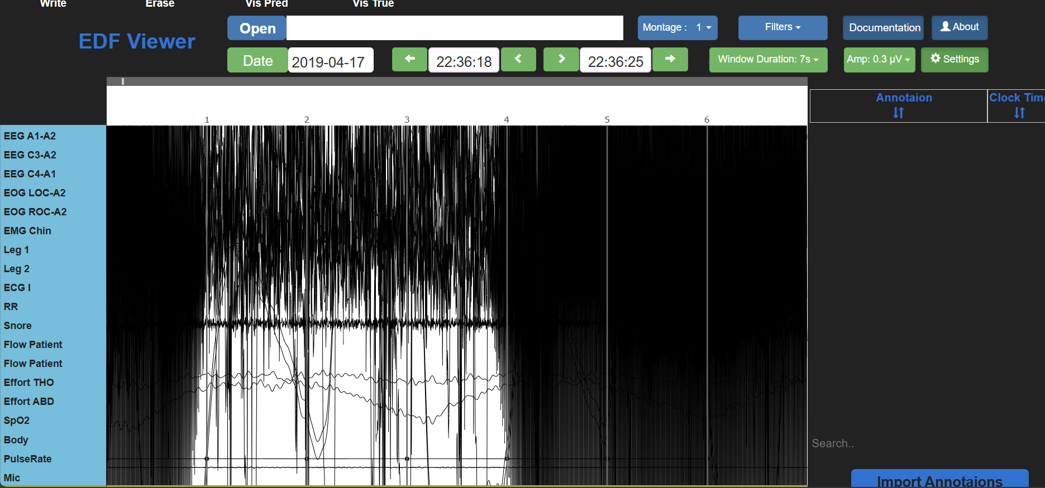

The blackness observed is mainly due to noise or not correct amplitude specification, adjusting amplitude or by applying filters we can reduce it.

In order to obtain the snoring signal, we need to apply a lowpass filter (20to200Hz) so that we obtain only our required signal and do our required analysis.